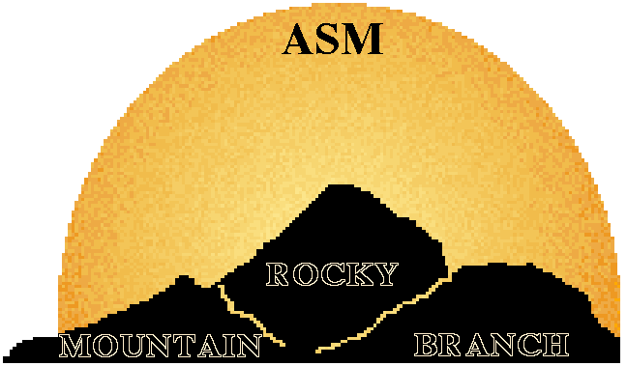

MEETING ANNOUNCEMENT

Rocky Mountain Branch
of the American Society for Microbiology

Fall meeting
Saturday, October 25, 2014
9:00 am

Worner Campus Center: Gaylord Hall
Colorado College
Colorado Springs, CO 80903

ASM Distinguished Lecture
Dr. Stephen Lory
Department of Microbiology and Immunology
Harvard Medical School
Genome-wide detection of virulence and host recognition determinants in Pseudomonas aeruginosa
Keynote Presentation
Dr. Phoebe Lostroh
Department of Molecular Biology
Colorado College
Motility and natural transformation in a soil bacterium

Free Meeting registration to all students
Free lunch to all pre-registered meeting attendees
Student & Postdoc Travel Awards available
$$$ Awards for top student & postdoc presentations $$$

Return this form to: torsten.eckstein@colostate.edu
Please write “RMB-ASM” in the subject line.
Fall 2014 Rocky Mountain Branch of ASM
Meeting Registration Form
Deadline: October 10, 2014

Name:

E-mail:

Status: Undergrad student Grad student Post-doc
Faculty Other (please specify)

Institution:

Registration for meeting (check one):

Student (U, G): Member: _____ FREE (but you must register)
Non-member: _____ FREE (but you must register)

Post-doc: Member: _____ $5.00 (fee waived if presenting talk or poster)
Non-member: _____ $10.00 (fee waived if presenting talk or poster)

Non-Student: Member: _____ $10.00
Non-member: _____ $20.00

Branch membership: (Annual) Student: ____ $5.00
Non-student: $15.00

Lunch is free to all pre-registered meeting attendees

Membership monies will be collected at the meeting. Cash or checks only. No credit cards please! We need to get an accurate count so please send in your registration.

All presenters must pre-register for the meeting. *If join or renew your branch membership using this form you may then pay the member registration rate.
Fall 2014 Rocky Mountain Branch of ASM

Intent to Present Form
Deadline: October 10, 2014

Name of Presenter:

Status: Undergrad student Grad student Post-doc Faculty Other

Institution:

Presentation type: ____Poster ____ 15 min talk
Author(s):

Title of Presentation:

Please use this format:
Experimental Tacaribe Virus Infection of Jamaican Fruit Bats. Tony Schountz*, Ann Cogswell*, Charles H. Calisher^ and Richard Bowen^. *University of Northern Colorado and ^Colorado State University.

Other than PowerPoint, A/V Needs for Oral Presentations: ____________________________
Fall 2014 Rocky Mountain Branch of ASM
Travel Award Application Form
Deadline: October 10, 2014

Applicant’s Name:

College or University:

Current student status: Undergraduate
Graduate

Travel Award Criteria: 1. Carpooling: please provide the name(s) of at
(both must be met) least one other student that will be carpooling with you to the meeting

2. Meeting Presenter: please indicate type of
presentation: oral
poster

This form must be returned to torsten.eckstein@colostate.edu no later than 5:00 p.m. on October 10, 2014. Awardees will be selected on a first-come-first served basis so the earlier you send the form back the better your chances of getting selected.

Directions
Meeting registration starts at 7:30 a.m. on October 25.
Worner Campus Center: Gaylord Hall

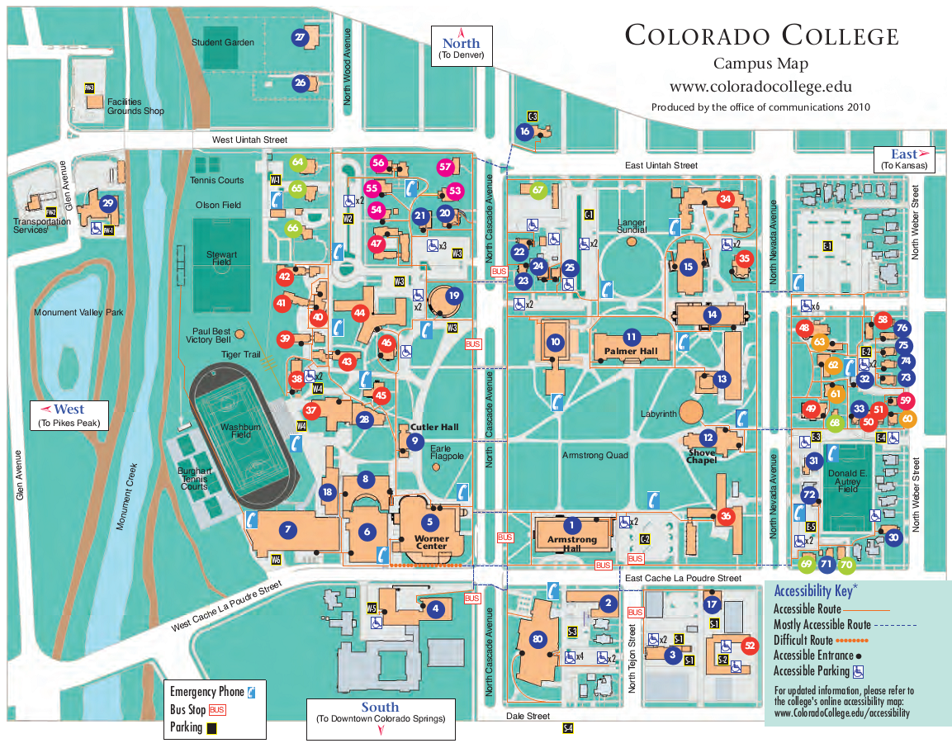
Meeting
Parking

